**Multimedia & Graphics**

**Class Six**

**Lab 15**

|  |
| --- |
| Lab Objectives: |

# Brush Tools

### Sketchy

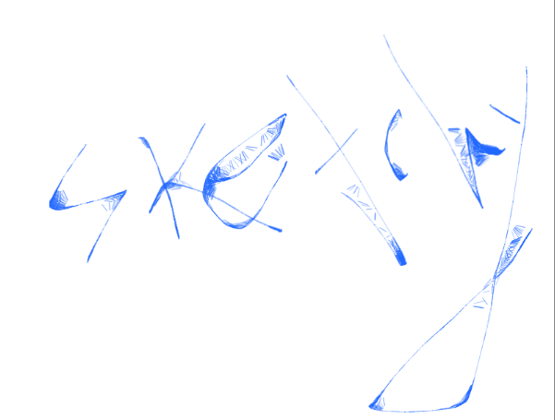

### Stamp

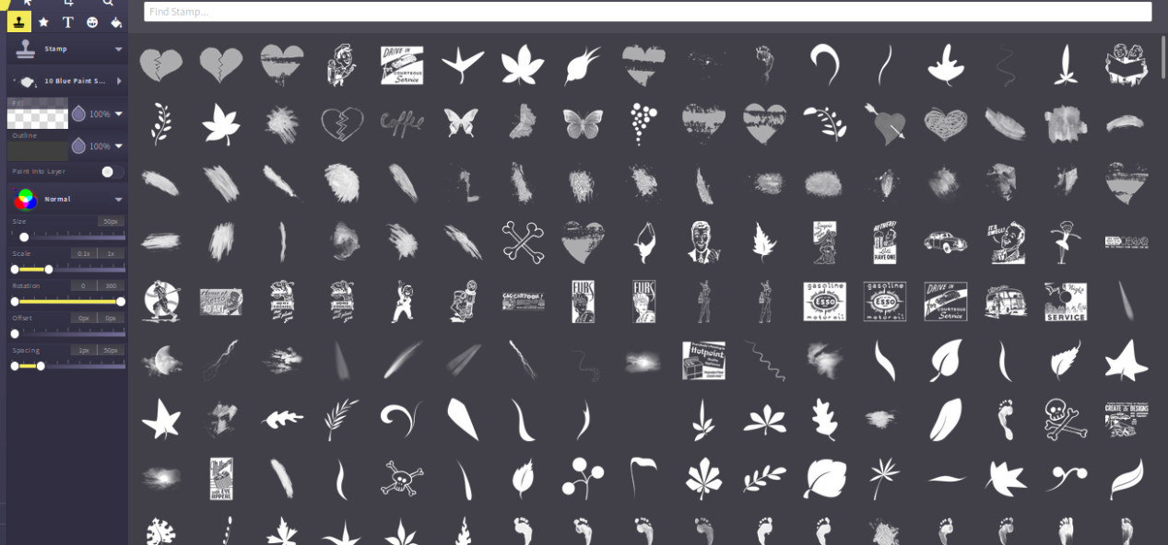

You can find lots of stamp under stamp brushes. Select one of them

* leaf

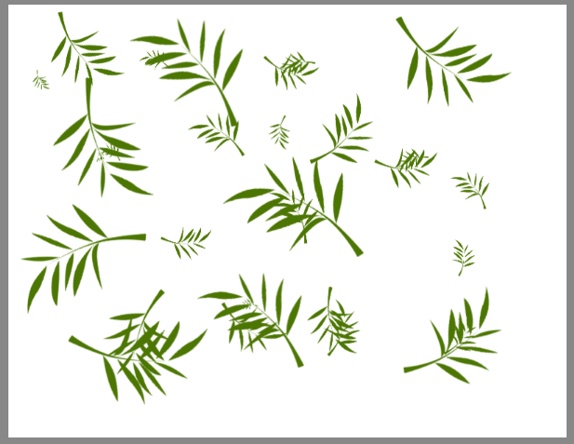

* Golfer

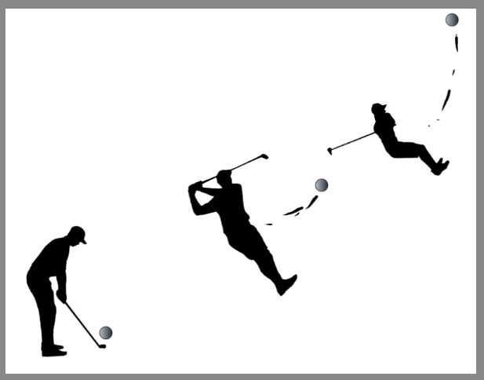

### Spray Paint

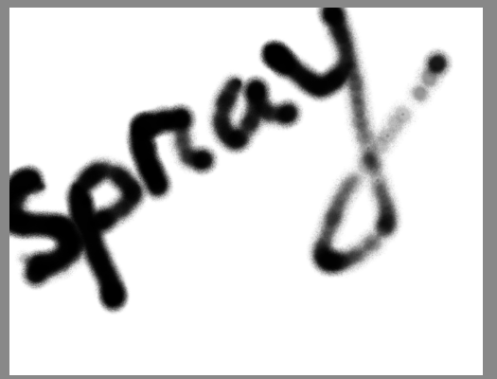

# Shape Tools

You can use different types of shapes from here. Use Select tool to move your object or resize them.

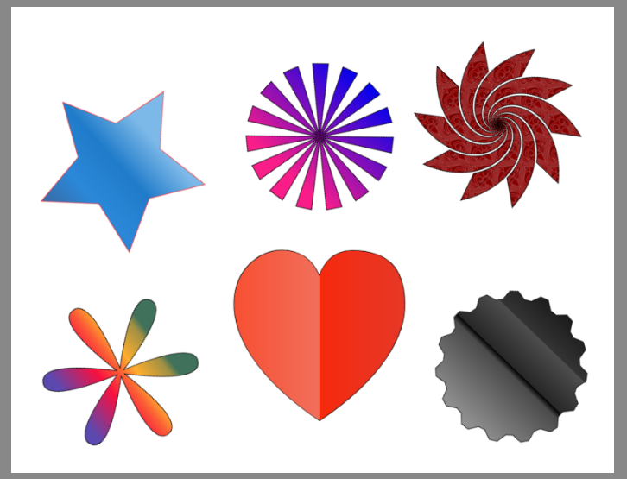

# Text Tools

You can use text tools to write anything. There are lots of fonts. Choose one of them and write anything.

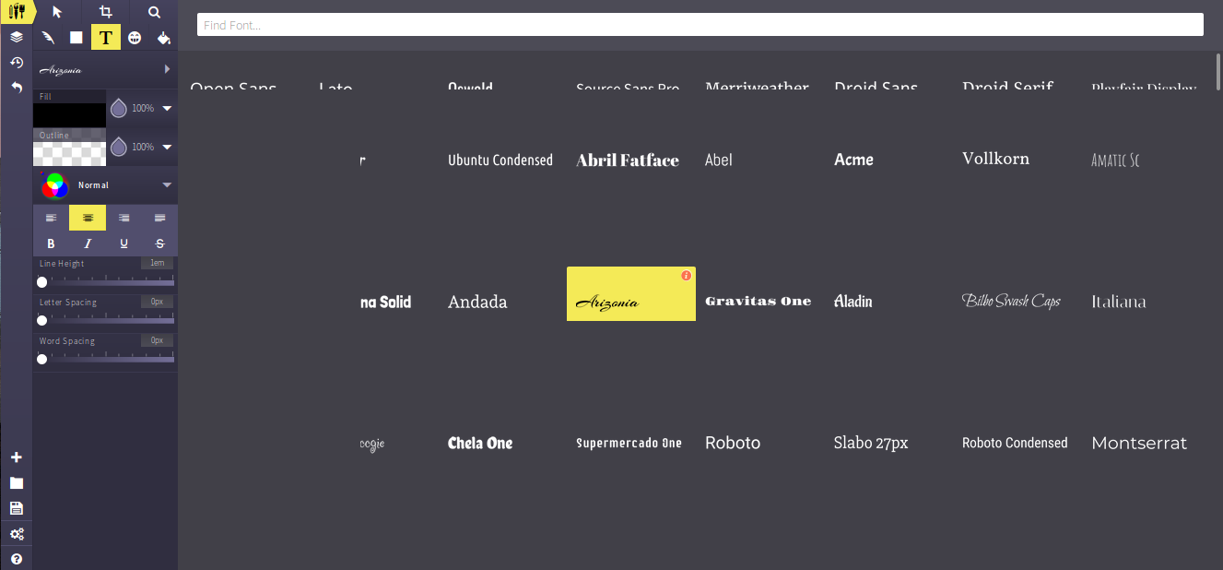

Write any thing

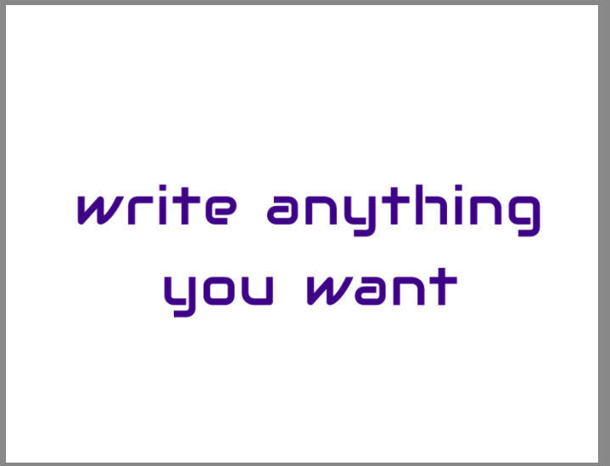

# Vector Tools

Color the background of your paint

Click vector icon and select any color

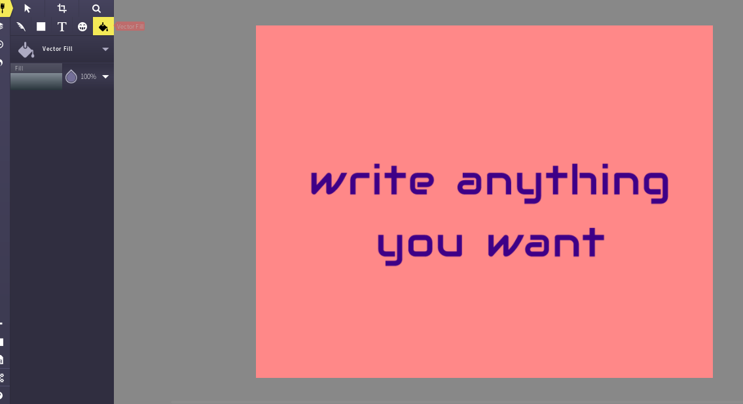

Using gradient color

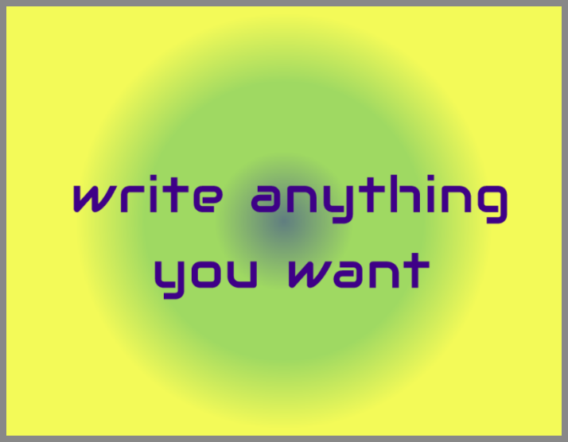

Using pattern background

